

**Project On**

**Mobile Balance Flexi load System**

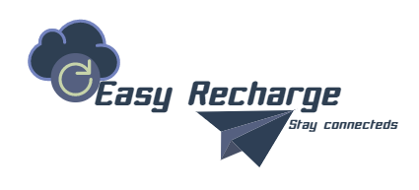

**Course Name: Information System Design**

**Course Code: CSE 306**

**Data of Submission: 10-01-2018**

**Submitted By Submitted To**

**Md.Rafiqul Islam A S Zaforullah Momtaz**

**ID: 15101059 Assistant Professor**

**Roll: 059 Dept. of CSE**

**Mobile Balance Flexi load System**

**Abstract :** Online Business system is a process that a person sitting on his chair in front of a computer can access all the facilities of the Internet to buy or sell the products. So Online Flexi load System is a best example where we can load our mobile balance whenever we want. Though in Bangladesh people are using different categories of sim cards.But to load balance in different sim cards, systems are not same. Often a picture flashes on our mobile screen that is **“Your Account Balance is TK 0.00”.**So to avoid this type of situation this system may play an important role.

**Introduction :** In Online Balance flexiload site where the consumer moves through the internet to a website. From there, he decides that he wants to purchase mobile balance, so he is moved to the online transaction server, where all of the information he gives is encrypted. Once he has placed his order, the information moves through a private gateway to a Processing Network, This generally takes place in no more than 30mins or 1hour.

**Purposes** :

* The wide availability of services for the consumer, easy accessibility, and international reach.
* This site is for good services over an electronic network, primarily the internet.
* Online Flexiload application provides customers more options and quicker delivery of mobile balance at any time whenever they need to load balance or what amount of balance the need.
* The purpose of this site is to load required balance within a secure way where customers have their reliability.

**Historical Back :** Before using mobile phones or telephone people

used telephone like…

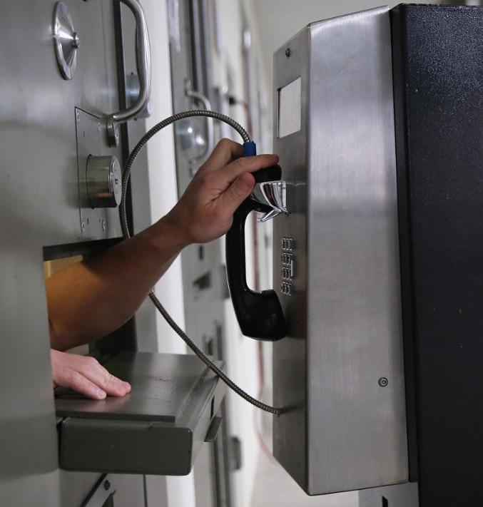

This system was very difficult to communicate with. Using mobile phone with this site Online **Mobile Balance Flexiload System** communication become so easy.

**Facilities Analysis** : In this site there is both advantages and

disadvantages.

* **Advantages :**
* 24x7 support. Customer can load balance for any amount provided by a company any time, any where from any location. Here 24x7 refers to 24 hours of each seven days of a week.
* Customers need not to travel to load balance, thus less traffic on road and low air pollution.
* Online Flexiload application provides customers more options and quicker delivery of mobile balance at any time.
* **Disadvantages :**
* Privacy and security. Before making online application for flexiload, must need to check the sites certificates of security.
* Sometimes delay in receiving the mobile balance in critical moment.

**System Organization** : This system is organized with three levels

Data Flow Diagram. They are…

* Data Flow Diagram Level 0
* Data Flow Diagram Level 1
* Data Flow Diagram Level 2

**Data Flow Diagram** : Data Flow Diagram is graphical representation of flow of data in an information system. It is capable of depicting incoming data flow, outgoing data flow and stored data.

* **Level 0 :** Highest abstraction level DFD is known as level-0 DFD which depicts the entire information system as one diagram concealing all the details.
* **Level 1 :** This DFD level Shows the total system organization using a diagram .There will be process, Entity relation , Order & customer details etc.
* **Level 2 :**This level shows the entity details and all information.

**Requirement Analysis :**

* **Software Requirements**
* **Hardware Requirements**
* **Human Resource**

**Software Requirements :**

**System development Softwere :**

* Operating system: Windows, Linux, Mac
* Development platform: Dreamweaver, Brackets
* Language: PHP, MySql
* Server: Apache
* HTML: HTML5
* Style sheet: CSS, JQuery

**User Required Softwere** :

* Operating system: Windows
* Browser: Firefox

**Hardware Requirements :**

* System development Hardwar
* CPU: Intel duel core, 3.0 GHz
* Ram: DDR3 2GB
* HDD: 640GB
* Monitor: Color monitor
* User required Hardwar
* CPU: Intel duel core, 2.0 GHz
* Ram: DDR2 1GB
* HDD: 50GB
* Monitor: Color monitor

**Human Resource :** Electronic commerce technologies are changing the way that work tasks are conducted and thus has significant implications for the way organizations manage their human resource functions. Although the impact of IT on work and employment has been the subject of research, little attention has been paid to electronic commerce and its effect on work organization and HR management. This paper examines existing literature on how technologies have shaped workplace management, with particular attention to the banking industry. It proposes a conceptual framework for identifying and understanding these changes in the context of the business pressures faced by banks in the highly competitive retail banking environment.

**Graph Representation** : The worldwide expansion of the internet has considerably contributed to the transformation of trade and store transactions. This site, largely means getting balance through the internet and is commonly associated with online shopping. This site also makes use of regular technological maintenance to ensure the smooth functioning of online store sites, monetary transactions, as well as everything to do with providing and delivering products.

**Security System :** There must be a secure gateway system in this site. For the security system, must need the system given below…

* **Create User ID with an Email (Sign Up)** : User have to sign up with an account using an email address.
* **User Login** : User can login with their valid email address whenever they want to load balance.
* **Match Email Address** : Confirm the email address with the address user created when they signed up. If the address is not matched user couldn’t purchase for balance.
* **User Logout** : After completing order user easily logout from their ID.

**Conclusion:** If we concern about our security system then this system will be very beneficial for us to sustain our communication system and we can go ahead. In future this site may develop by improving necessary facilities within a systemic way.